TITLE OF PAPER

Name Surname¹, Name Surname², Name Surname³, Name Surname⁴, Name Surname⁴

¹Institution
²Institution
³Institution
⁴Institution

Key words: word1. word2, wor3, wor4, word5

Abstract: Text….

INTRODUCTION

Table 1 Name of table
R_{m} / N/mm

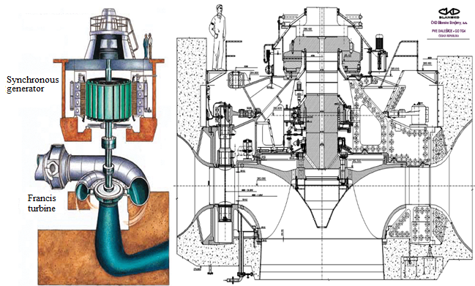
Figura 1. Name of figure

NON - DESTRUCTIVE TEST PERFORMED ON THE VITAL WELDED JOINT

Text…..

Visual testing

Text…

CONCLUSION

Text…

Acknowledgement

Text…..

REFERENCES

[1] Wang, Y., Li, F., Yu, H., Wang, Y., Qi, C., Yang, J., & Song, F. (2020). Optimal operation of microgrid with multi-energy complementary based on moth flame optimization algorithm. Energy Sources, Part A: Recovery, Utilization, and Environmental Effects, 42(7), 785-806.

